1. **Integrate EJB3 with Spring Boot**

## Overview

In this post, we'll have a look how to Integrate existing EJB3 Application whichs is runing on wildfly with Spring Boot Application and expose as REST.

## Setting up the EJB3 project

Create a new maven project in eclipse

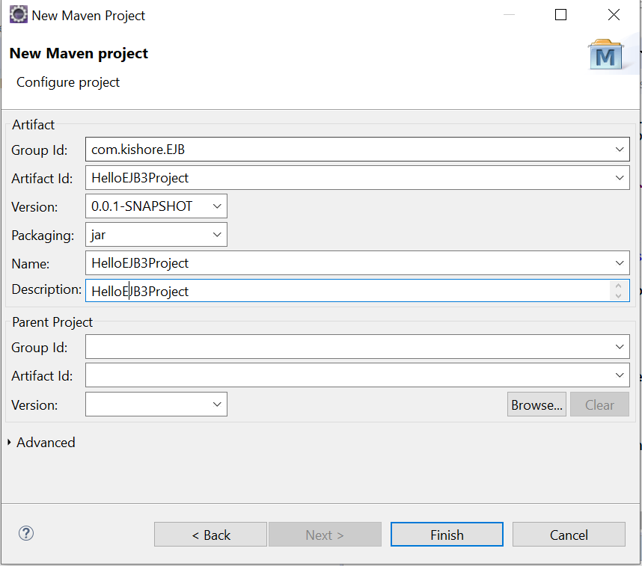

Convert Project Facet to EJB3.2

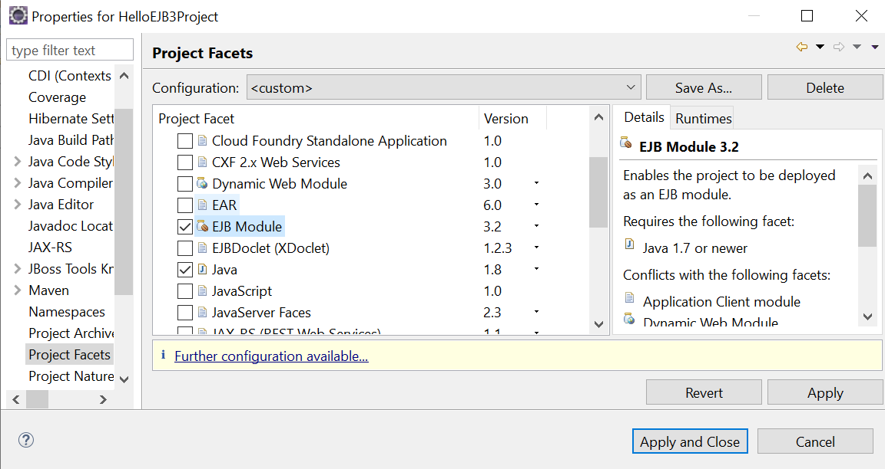

Add server Runtimes

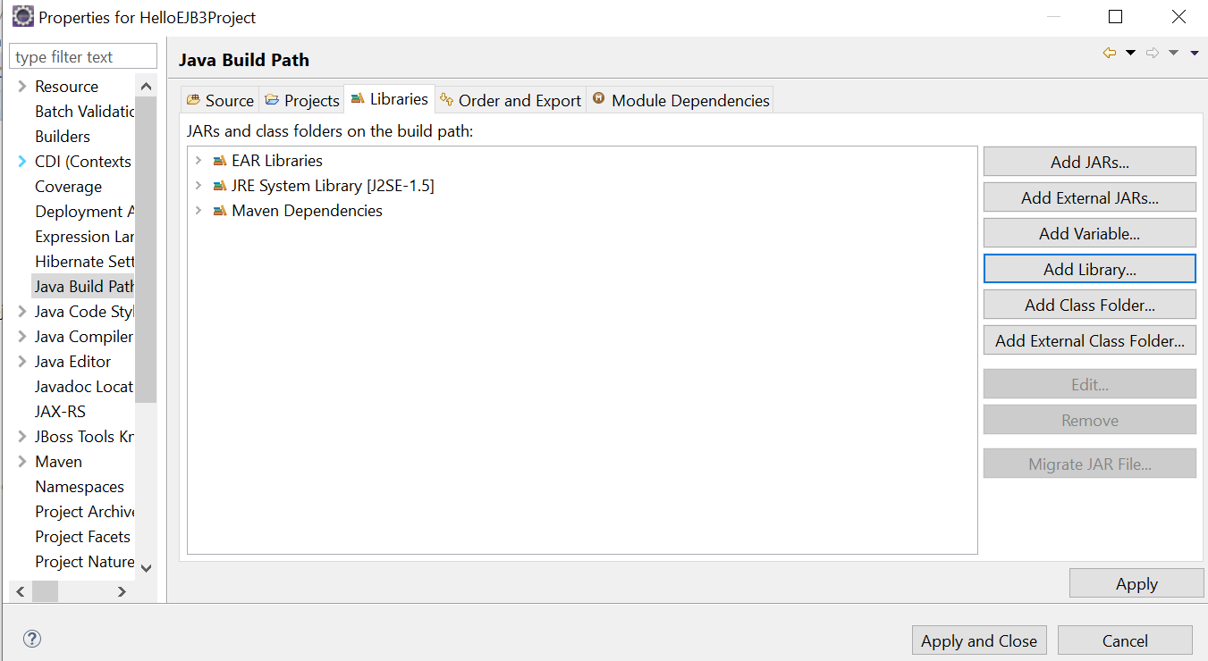

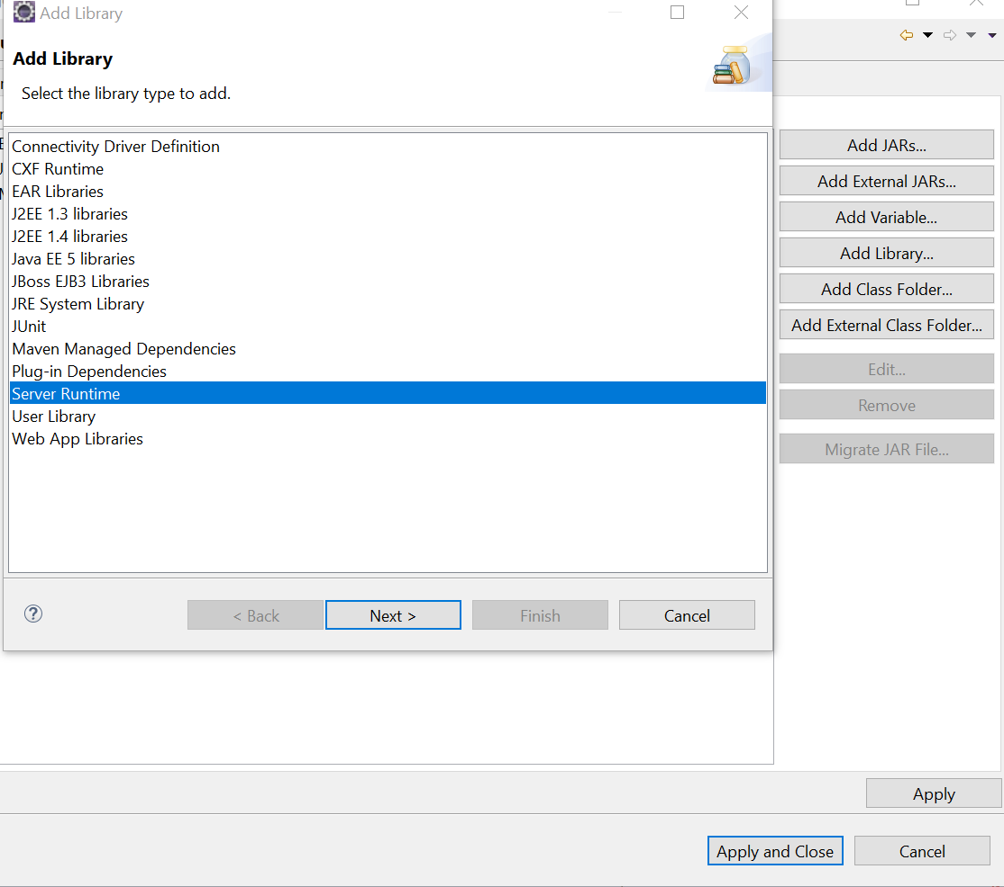

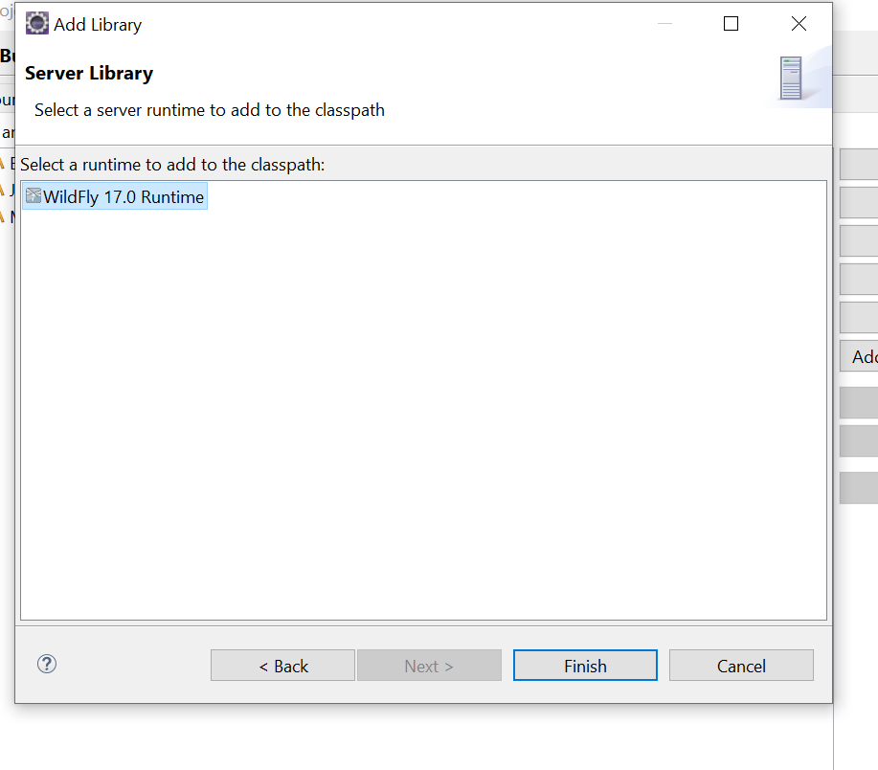

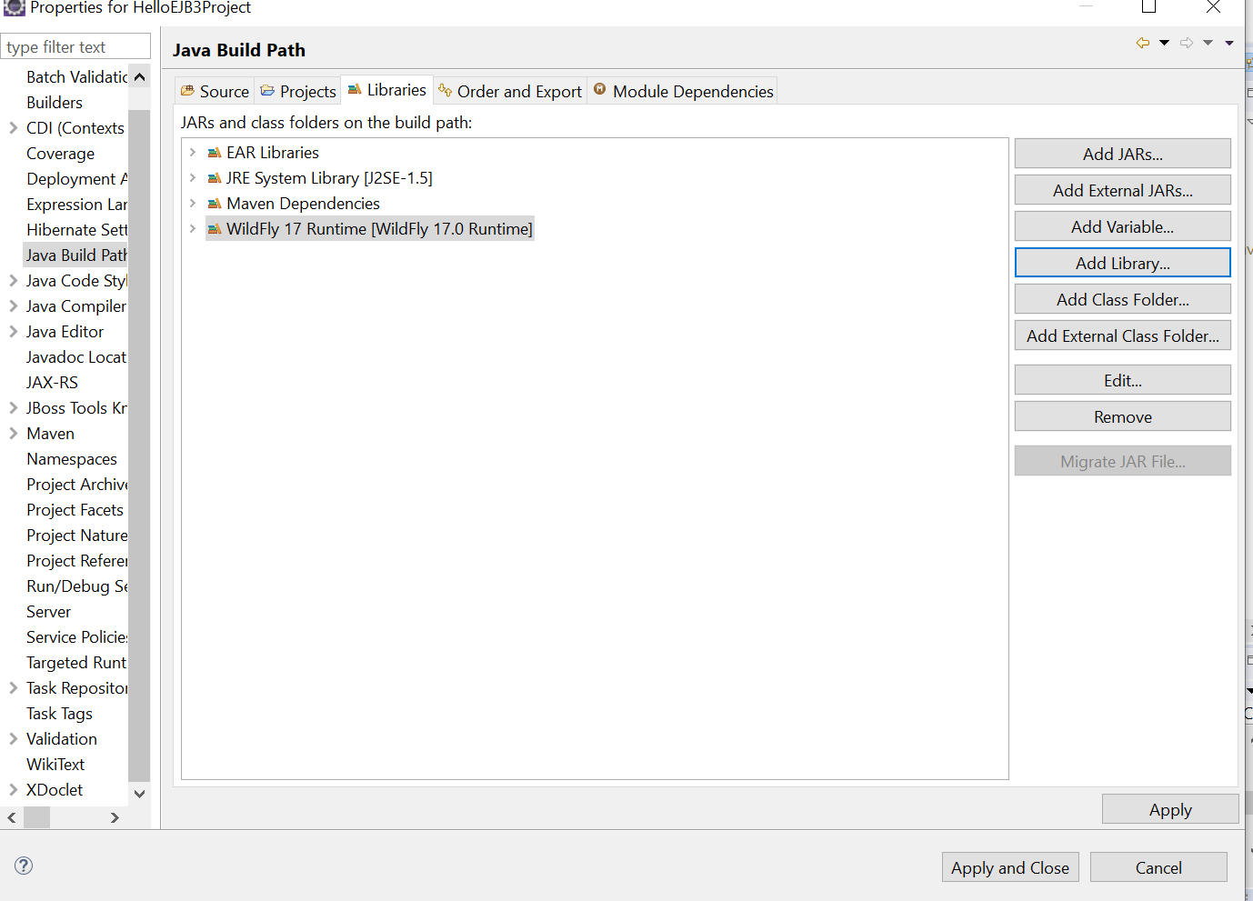

Add maven dependency

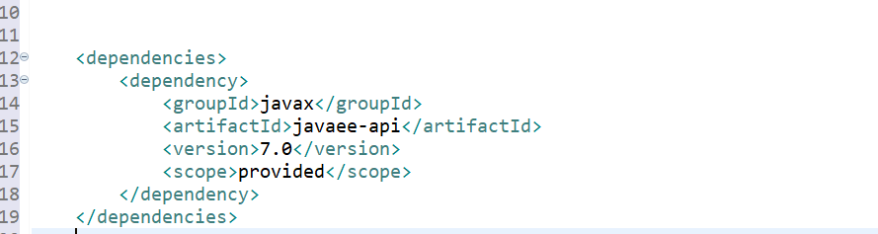

Add build profile with org.wildfly. plugin. This plugin can be used to deploy, redeploy and undeploy applications to a WildFly

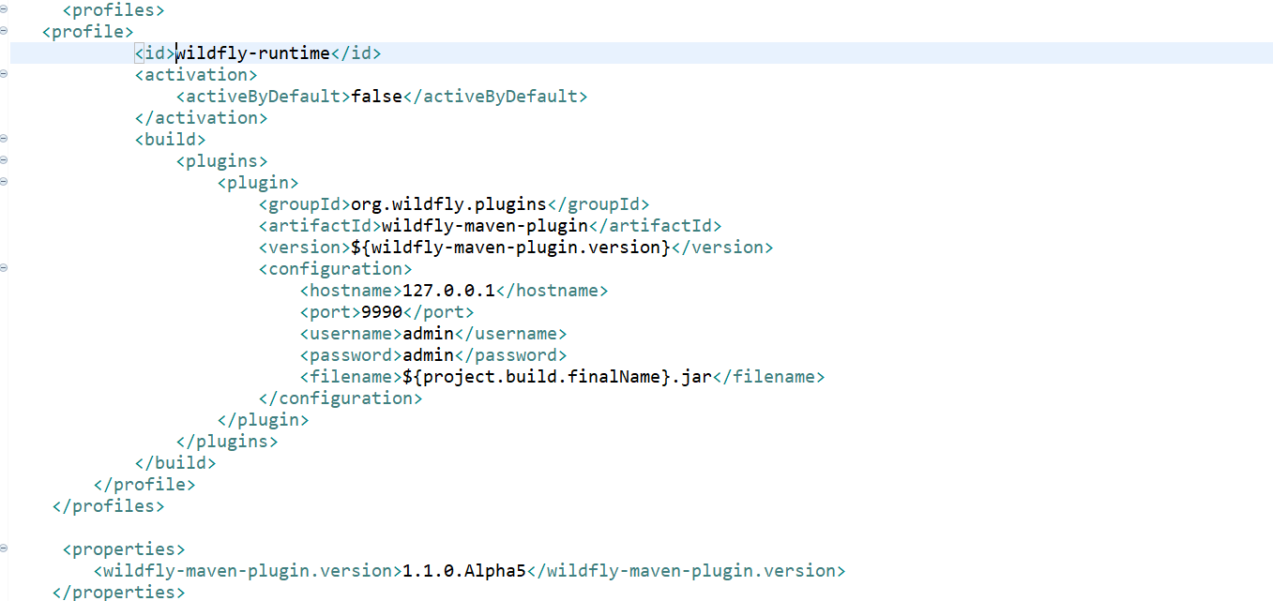

Create Statless HelloBean

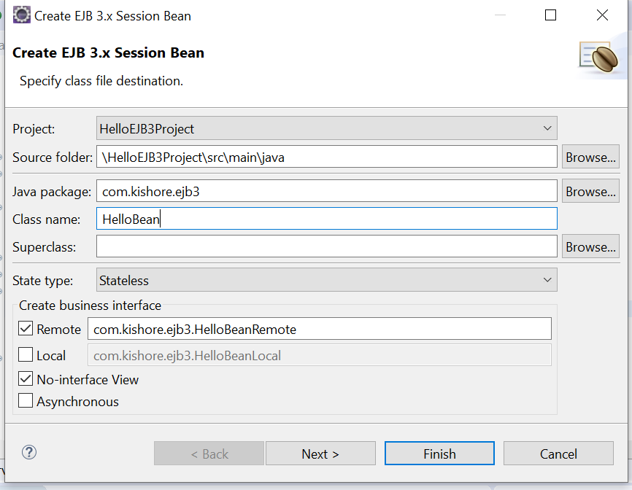

Create a new method in EJB bean and Remote Interface

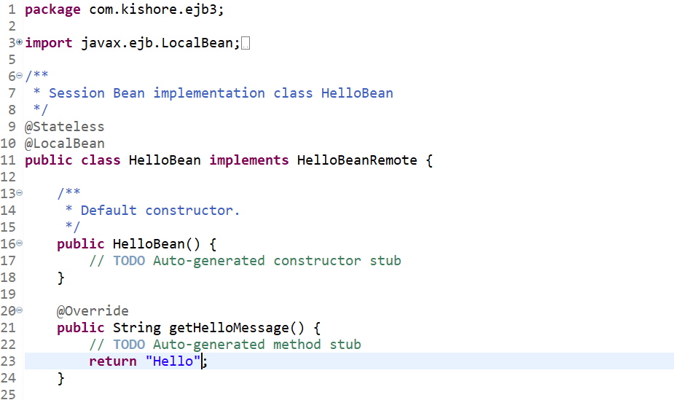

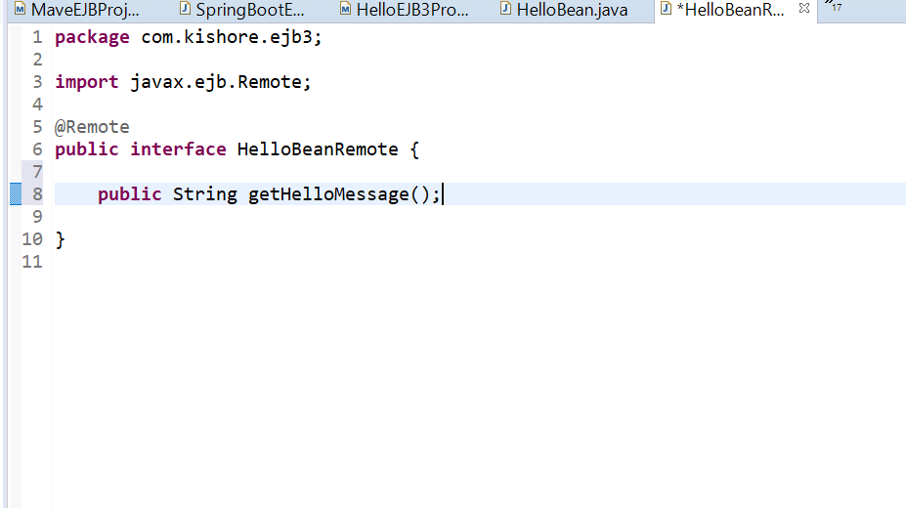

Package the Jar with mvn Package

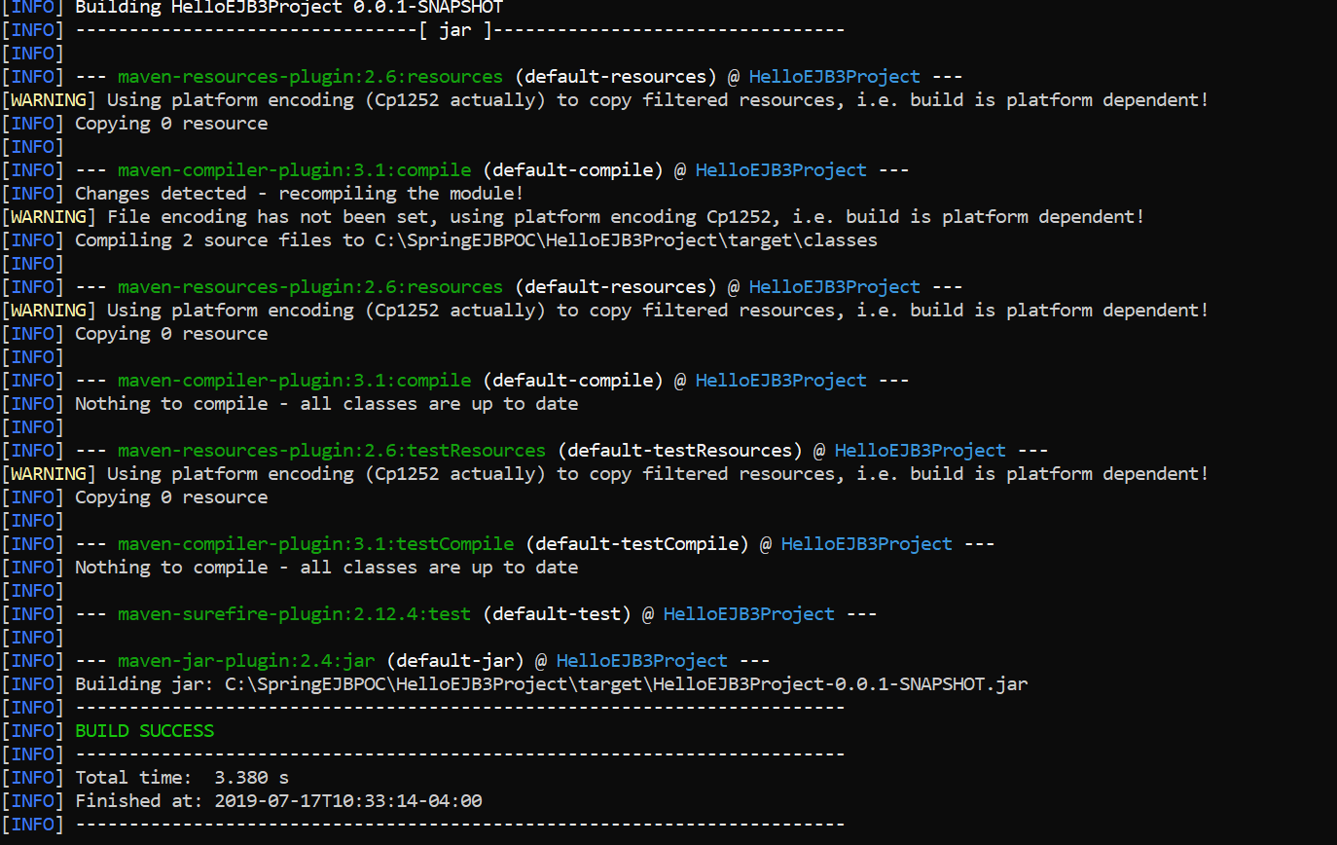

Run the following mvn command to add your own jar to maven loacal repositry so it can be used as dependency in other projects.

mvn install:install-file -Dfile=target\HelloEJB3Project-0.0.1-SNAPSHOT.jar -DpomFile=pom.xml -Dsources=target\HelloEJB3Project-0.0.1-SNAPSHOT.jar

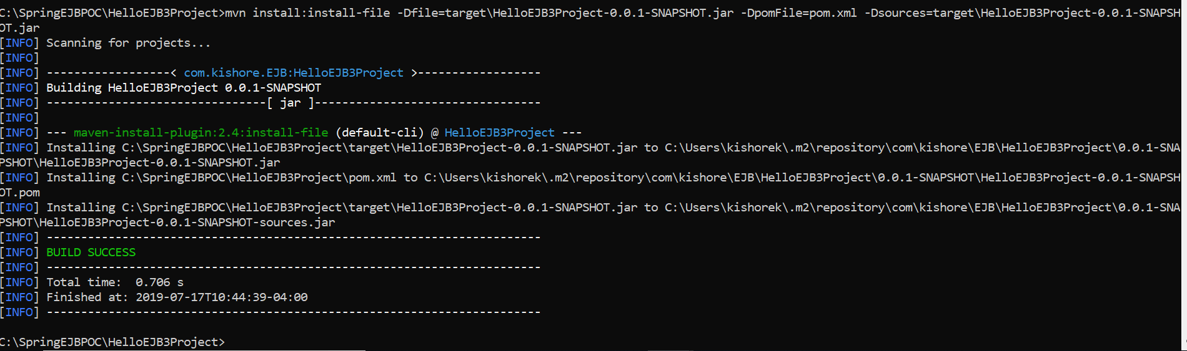

Deploy the Application on Wildfly server by using following Maven command

mvn clean install wildfly:deploy -Pwildfly-runtime

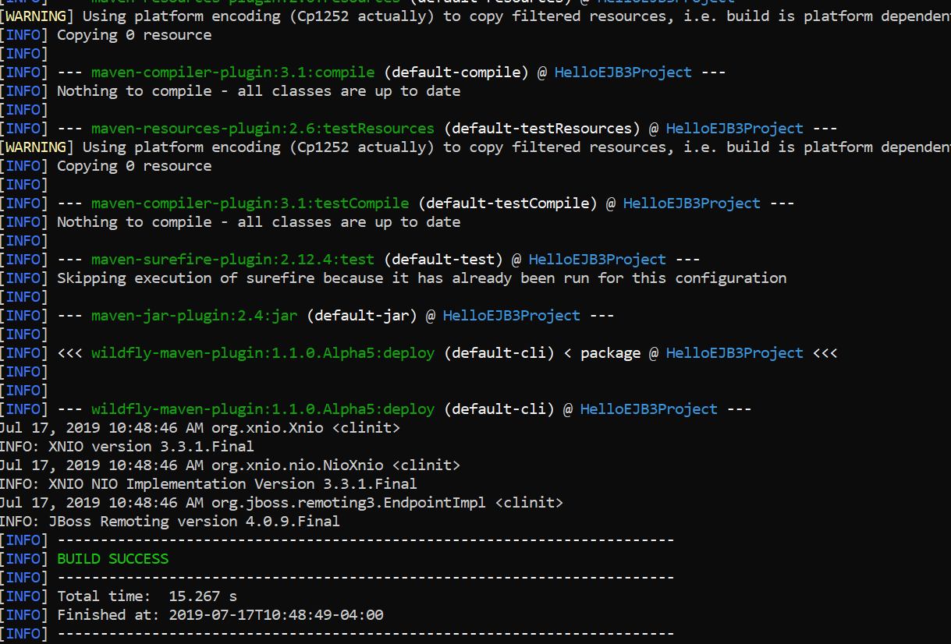

Application deployed succesfully on Wildfly server.

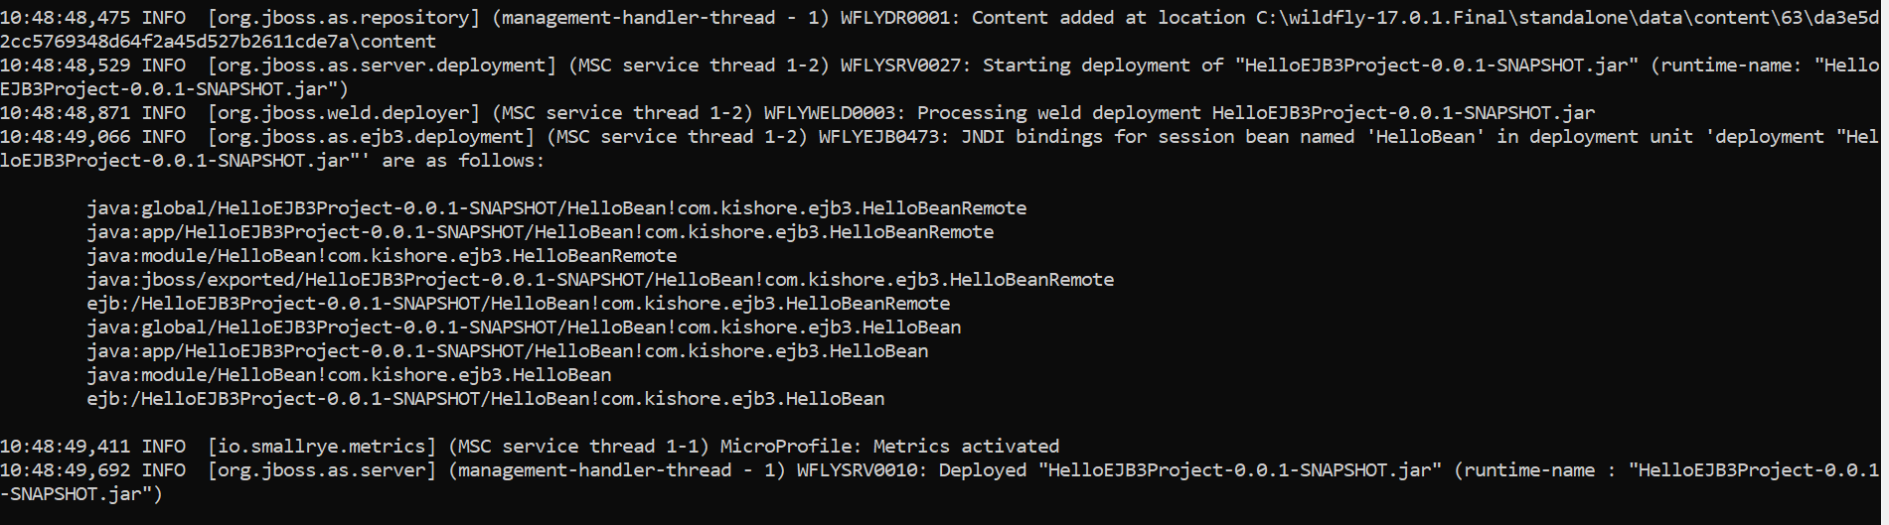

## Invoke EJB3 Application from Spring Boot Application which is deployed on default embedded containers.

Create a spring Boot starter Project

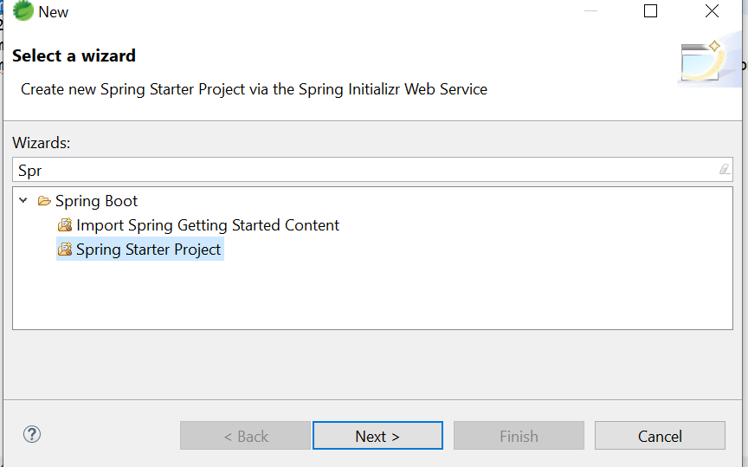

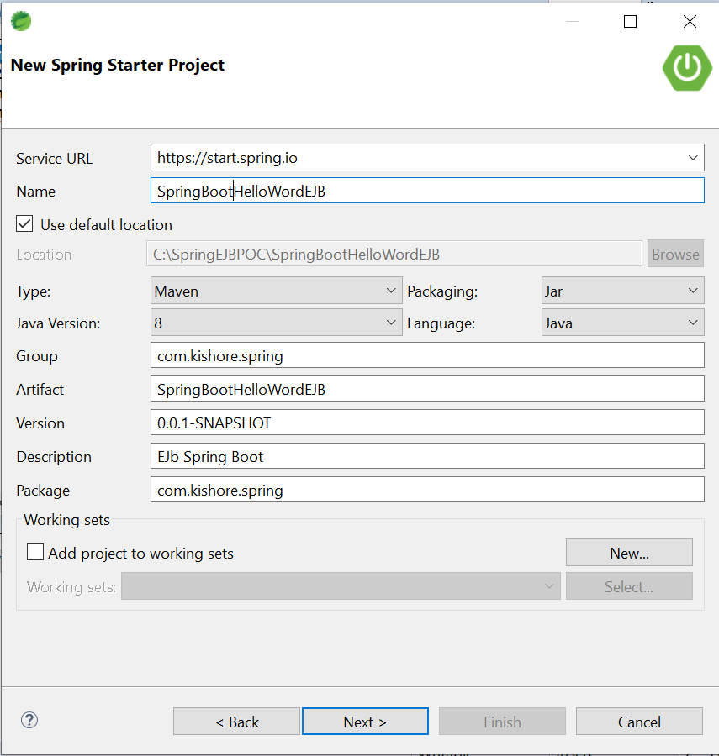

Add Jboss Client jars as third party jars to maven local repository

mvn install:install-file -Dfile=C:\wildfly-17.0.1.Final\bin\client\jboss-cli-client.jar -DgroupId=org.jboss -DartifactId=jboss-cli-client -Dversion=1.0 -Dpackaging=jar

Add Jboss Client jars as maven dependency which added as third party jars in above step

<dependency>

<groupId>org.jboss</groupId>

<artifactId>jboss-cli-client</artifactId>

<version>1.0</version>

</dependency>

<dependency>

<groupId>org.jboss</groupId>

<artifactId>jboss-client</artifactId>

<version>1.0</version>

</dependency>

Add HelloEJB3Project jar as maven dependency which added as third party jar in previous step

<dependency>

<groupId>com.kishore.EJB</groupId>

<artifactId>HelloEJB3Project</artifactId>

<version>0.0.1-SNAPSHOT</version>

</dependency>

Maven dependencies

<dependencies>

<dependency>

<groupId>org.springframework.boot</groupId>

<artifactId>spring-boot-starter-web</artifactId>

</dependency>

<dependency>

<groupId>org.springframework.boot</groupId>

<artifactId>spring-boot-devtools</artifactId>

<scope>runtime</scope>

<optional>true</optional>

</dependency>

<dependency>

<groupId>org.springframework.boot</groupId>

<artifactId>spring-boot-starter-test</artifactId>

<scope>test</scope>

</dependency>

<dependency>

<groupId>com.kishore.EJB</groupId>

<artifactId>HelloEJB3Project</artifactId>

<version>0.0.1-SNAPSHOT</version>

</dependency>

<dependency>

<groupId>org.jboss</groupId>

<artifactId>jboss-cli-client</artifactId>

<version>1.0</version>

</dependency>

<dependency>

<groupId>org.jboss</groupId>

<artifactId>jboss-client</artifactId>

<version>1.0</version>

</dependency>

<dependency>

<groupId>javax.ejb</groupId>

<artifactId>javax.ejb-api</artifactId>

<version>3.2</version>

</dependency>

<dependency>

<groupId>io.undertow</groupId>

<artifactId>undertow-servlet</artifactId>

</dependency>

</dependencies>

Configure Spring Boot Application with HelloBeanRemote Object

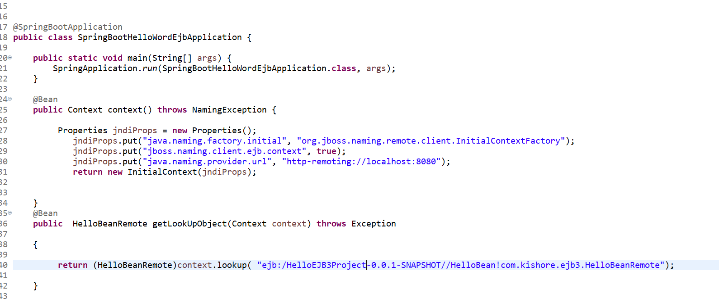

Create HelloWordController RestController class

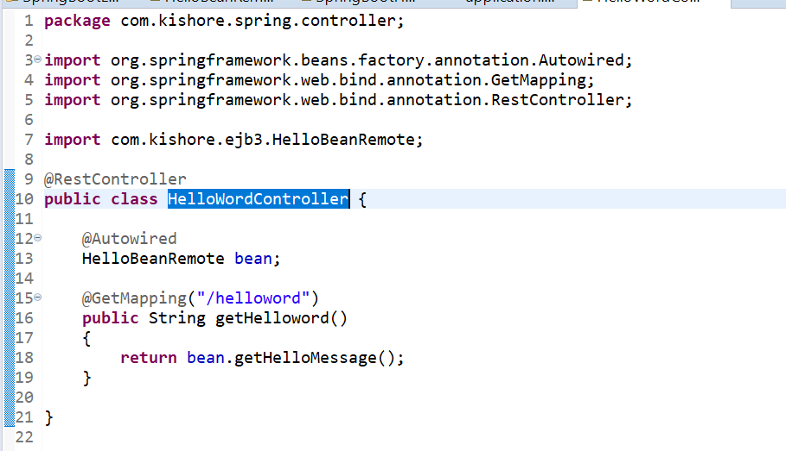

Add server port number as 8183 in my localbox 8080 binded to other application

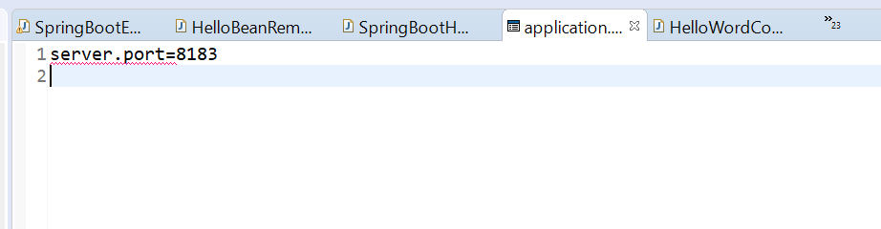

Run the application as Spring Boot App and test the application in postman.

<http://localhost:8183/helloword>

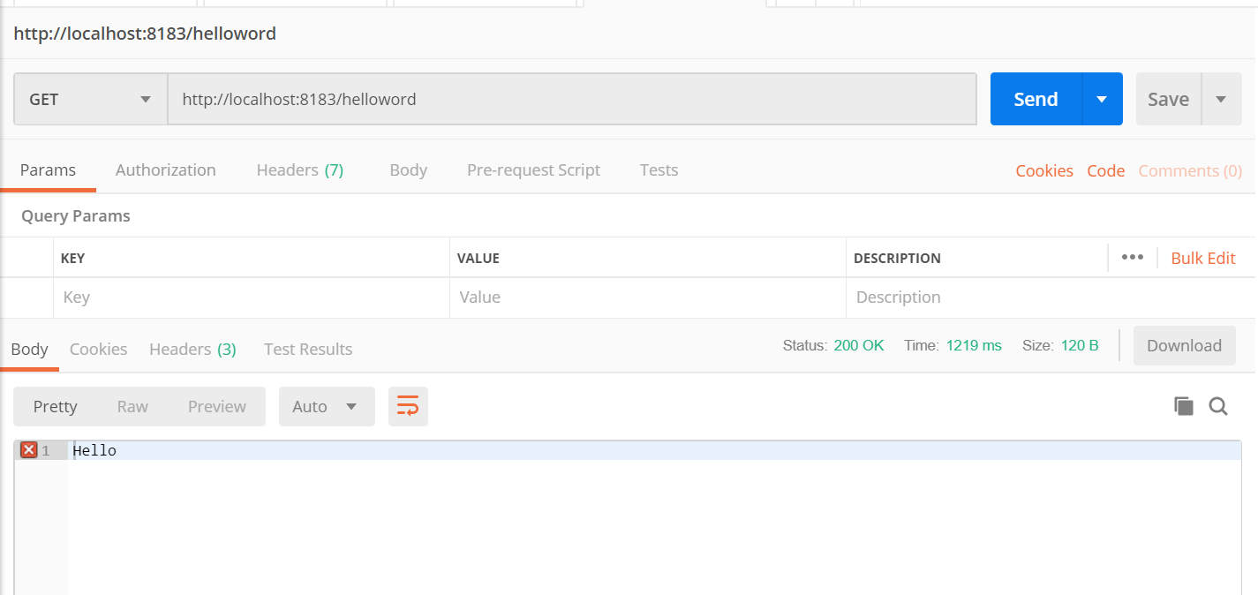

## Invoke EJB3 Application from Spring Boot Application which is deployed on External container(Wildfly).

Create a new project

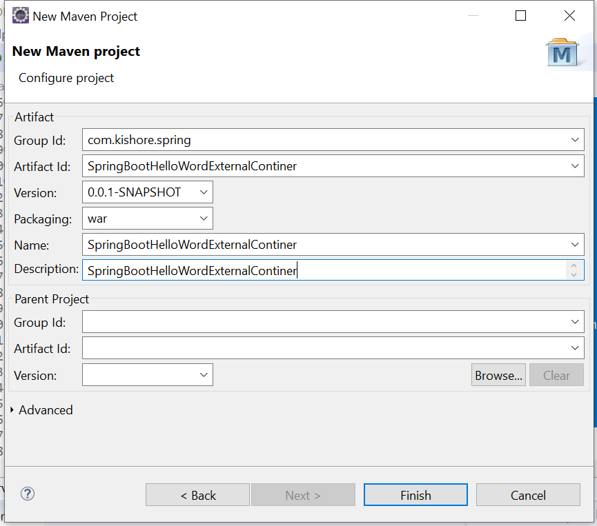

Exclude the embaded tomact conatiner

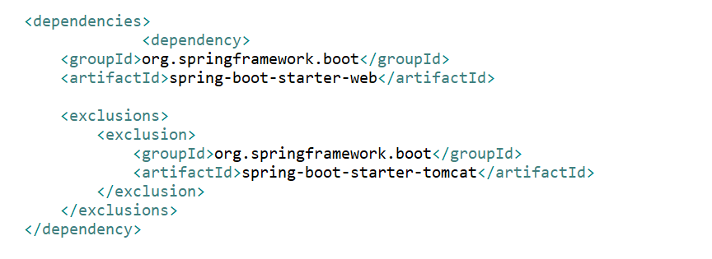

Add Maven dependency

<dependencies>

<dependency>

<groupId>org.springframework.boot</groupId>

<artifactId>spring-boot-starter-web</artifactId>

<exclusions>

<exclusion>

<groupId>org.springframework.boot</groupId>

<artifactId>spring-boot-starter-tomcat</artifactId>

</exclusion>

</exclusions>

</dependency>

<dependency>

<groupId>org.springframework.boot</groupId>

<artifactId>spring-boot-starter-websocket</artifactId>

<exclusions>

<exclusion>

<groupId>org.springframework.boot</groupId>

<artifactId>spring-boot-starter-tomcat</artifactId>

</exclusion>

</exclusions>

</dependency>

<dependency>

<groupId>com.kishore.EJB</groupId>

<artifactId>HelloEJB3Project</artifactId>

<version>0.0.1-SNAPSHOT</version>

</dependency>

<dependency>

<groupId>org.jboss</groupId>

<artifactId>jboss-cli-client</artifactId>

<scope>compile</scope>

<version>1.0</version>

</dependency>

<dependency>

<groupId>org.jboss</groupId>

<artifactId>jboss-client</artifactId>

<scope>compile</scope>

<version>1.0</version>

</dependency>

<dependency>

<groupId>javax</groupId>

<artifactId>javaee-api</artifactId>

<version>7.0</version>

<scope>compile</scope>

</dependency>

<dependency>

<groupId>javax.ejb</groupId>

<artifactId>javax.ejb-api</artifactId>

<version>3.2</version>

<scope>compile</scope>

</dependency>

<dependency>

<groupId>org.reactivestreams</groupId>

<artifactId>reactive-streams</artifactId>

</dependency>

</dependencies>

Add Profile deploy on wildfly

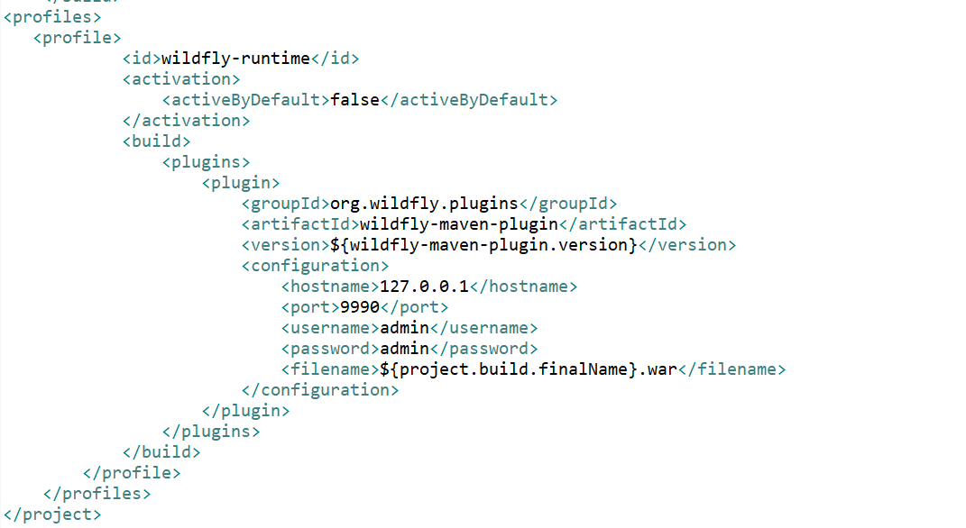

Add Configuration in Spring Boot App

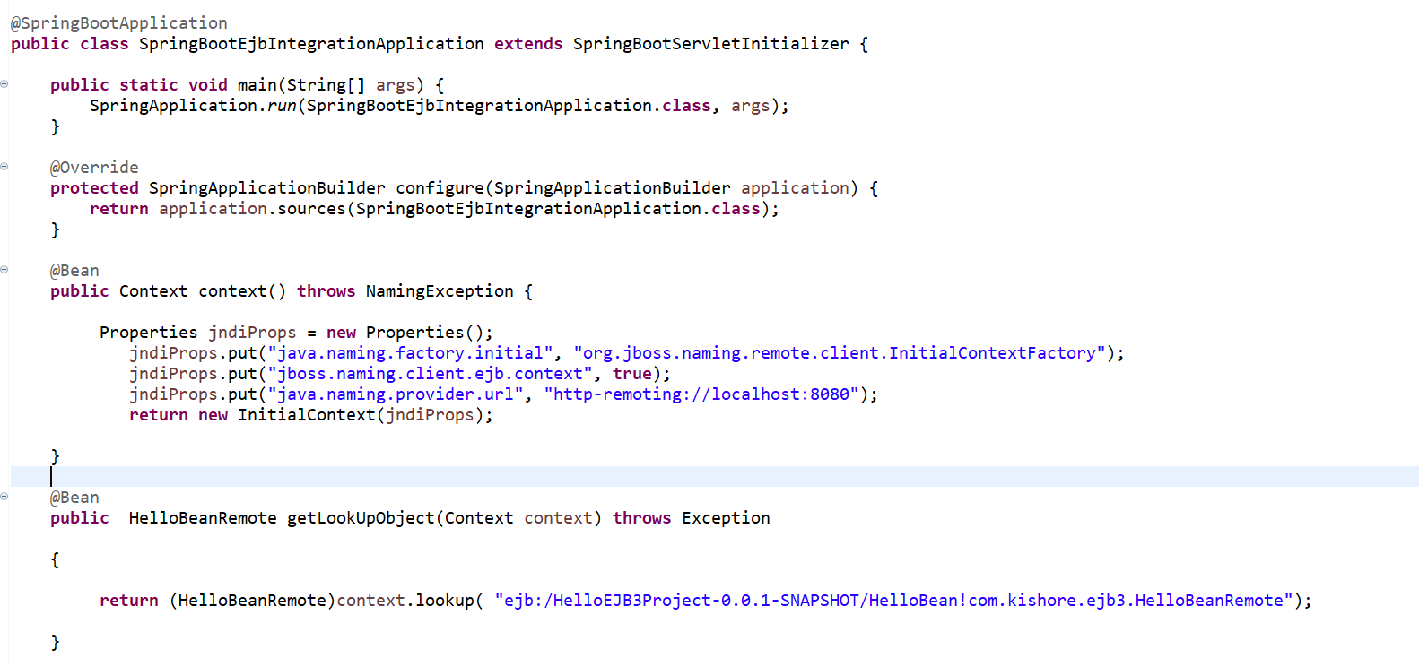

Create Rest Controller

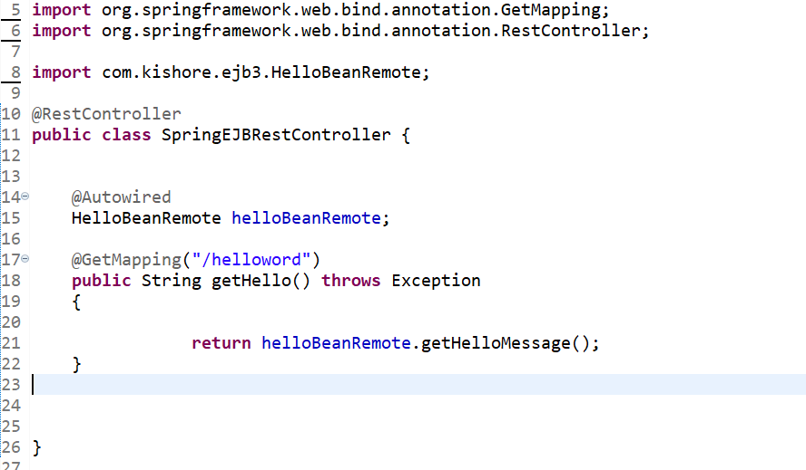

Run the mvn compile package command

Deploy the application on wildfly server

mvn clean install wildfly:deploy -Pwildfly-runtime or Replace the war file directly in deployment directory

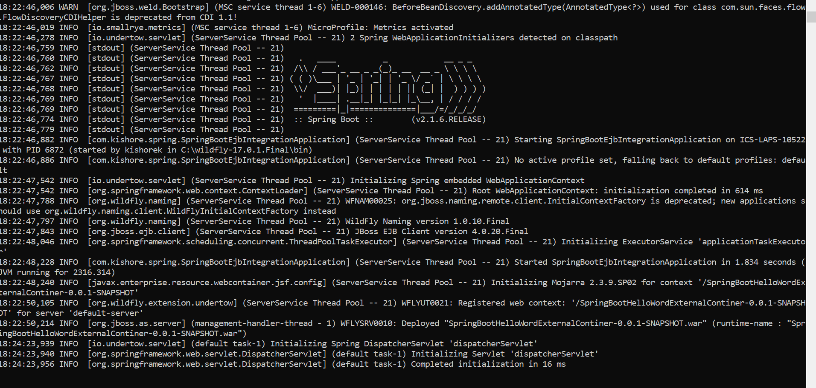

<http://localhost:8080/SpringBootHelloWordExternalContiner-0.0.1-SNAPSHOT/helloword>

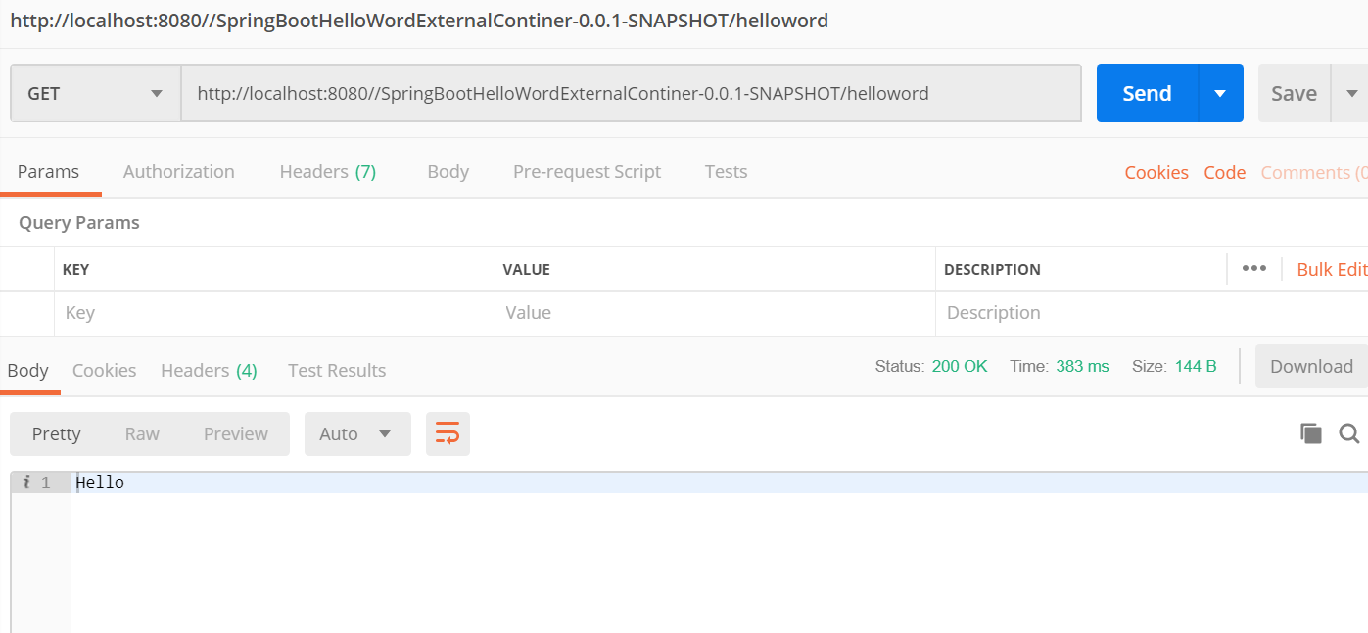

Please find the code in github: <https://github.com/kanuparthikish/SpringEjb3Integration>